**ECE 458**

**Spring 2020**

**Plan and Schedule**

**ECE – 6 TV Auto Commercial Mute System (MuteBot)**

**Report Submitted: February 4, 2020**

We, the undersigned, certify that we contributed to the generation of this report and attest to the validity of the data herein:

**Team Members:**

Steven Ferreira _____________________

Thomas Morrissey _____________________

Kevin Prairie _____________________

Zachary Taylor _____________________

**Customer:**

Dr. Paul J. Fortier

**Advisor:**

Dr. David P. Rancour

**Table of Contents**

Abstract 4

1 Introduction 4

2 System Overview 4

2.1 Concept of Operation 4

2.2 Functional Architecture Diagram 5

3 Customer Requirements 6

4 Engineering Requirements 7

4.1 Constraints 9

5 Standards 10

6 Resource & Cost Summary 11

7 Schedule 12

**List of Tables**

Table 1: Customer Requirements 6

Table 2: Customer to Engineering Requirements 7

Table 3: Resources Summary & Cost 11

Table 4: ECE 458 Plan & Schedule 13

**List of Figures**

Figure 1: Concept of Operation 5

Figure 2: Functional Architecture Diagram 6

# Abstract

The TV Commercial Auto-Mute system, or MuteBot, is being created to combat the initial volume spike that commercials use to quickly grab the attention of a viewer. In order to plan accordingly for the upcoming challenges in the development phase, a detailed schedule and outline has been created. Since the Preliminary Design Review, nothing has changed in the design of the system, thus the team is proceeding forward in development. The schedule is broken up into different tasks and subtasks that must be completed for the project to be finished. This report will highlight these tasks as well as review the overall design.

# Introduction

Since the Preliminary Design Review, the requirements, constraints and standards have stayed the same. At this stage of the project, work and prototyping for the major components of the system has begun. In order to track progress of the system and to hold the team accountable for tasks and subsystems to be completed, a detailed schedule has been created with a planned timeline for completion. Since the beginning of the semester, the commercial detection and the TV remote programs have been the main focus for the team.

# System Overview

The MuteBot system diagrams are used to provide a general overview of how the system should operate. The MuteBot system was broken down into different subsystems for prototyping including IR communication, commercial detection, and the physical design of the system’s housing.

## Concept of Operation

The design displayed in Figure 1 is a concept of operation. The concept of operation remains the same from the previous semester. This design provides a general external overview of the project. It highlights where the system should connect into an existing entertainment center set-up as well as what each component in the system should be doing. The system is perpetually powered by a standard US 120-volt wall outlet. The system initiates when the power button on the infrared remote is pressed. Once this is activated, the MuteBot will begin running its detection algorithm. It will begin this process by taking 3.5mm audio signals and sending them to the processor for real-time processing. Once the algorithm senses what it believes to be a commercial, the MuteBot will mimic the IR mute signal of the TV brand, which will result in the TV being muted. When the MuteBot believes the TV programming has returned the MuteBot will mimic the same signal to unmute the TV.

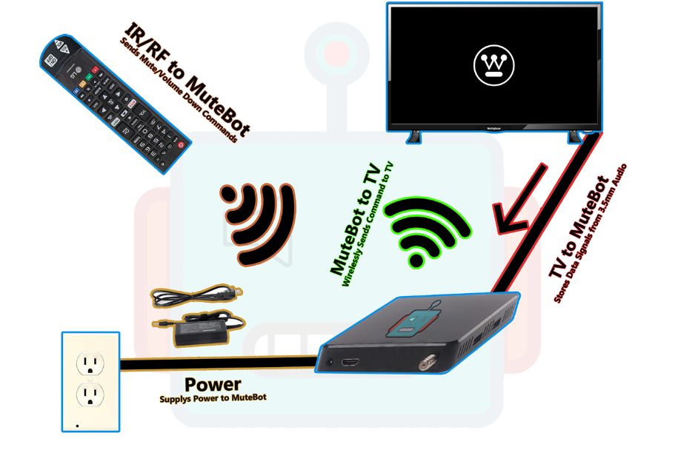

Figure 1: Concept of Operation

## Functional Architecture Diagram

In Figure 2, a functional architecture diagram is used to give a full overview of the subsystems and components that will make up the full MuteBot system. The full system has been broken down into 3 main categories: Signal Processing & Volume Control, Mounting System, and the Remote Control. Within each subsystem includes different componenets and aspects needed to meet the customer requirements for the system. Since the PDR, there have been no changes to the functional architecture diagram.

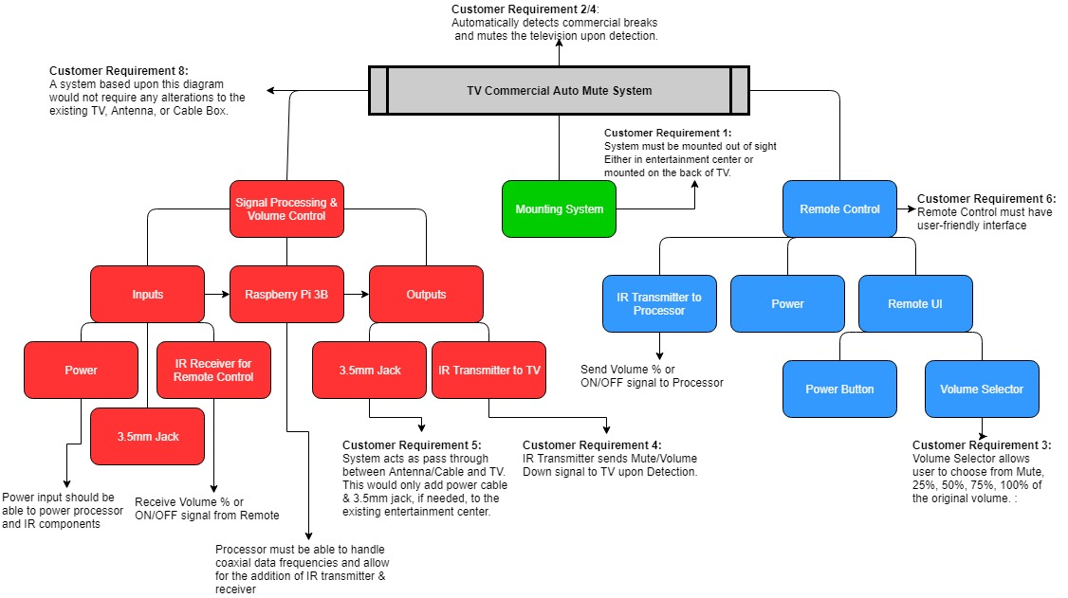

Figure 2: Functional Architecture Diagram

# Customer Requirements

Table 1 provides the customer requirements for the MuteBot system. Since the Preliminary Design Review, the customer requirements for the MuteBot have not changed. However, the second requirement is subject to change due to the unknown difficulty of delaying a live television broadcast and if it will be needed using the commercial detection methods that the team plans to use. More research and prototyping need to be done to determine the feasibility and necessity of the delay before the requirement is updated or removed.

Table 1: Customer Requirements

|  |  |
| --- | --- |
| Customer Requirement Number | Requirement Description |
|  | System must not obstruct the TV Screen. It must be able to be kept out of sight. |
|  | System must appear preemptive to the user, but can delay the broadcast by 10 seconds for improvement of accuracy. |
|  | System must allow user to choose to mute completely or lower volume when a commercial is detected. |
|  | System must mute or lower volume upon break and unmute or return to original volume upon return. |
|  | System must be simple to initially set up. |
|  | System must have a user-friendly interface/remote. |
|  | System cost must be competitive with competition. |
|  | System must refrain from any alterations to the TV or its remote control. |

# Engineering Requirements

Table 2 takes the customer requirements described in Table 1 and breaks them down into quantifiable and testable engineering requirements. The engineering requirements have not changed for the system since the Preliminary Design Review. Such as with the customer requirements, engineering requirement 2 is subject to change until more research and prototyping is done to gain a better understanding of the delay. The questionnaire created for user-review tests has also stayed the same since the last report and can be found in the team’s folder.

Table 2: Customer to Engineering Requirements

|  |  |  |  |  |
| --- | --- | --- | --- | --- |
| Rqmt. # | Customer Requirement | Engineering Requirement | Justification/Comments | Test Method (IADT) |
|  | System must not obstruct the TV screen. It must be able to be kept out of sight. | System can have a cable box at most, rest of system must remain behind the TV. | The system must not be obtrusive to ensure the user has a clear and not obstructed viewing experience. | Inspection:  User-Review/Observation  This will be measured via a questionnaire. Any category in the questionnaire labeled 3 or lower will be deemed not acceptable and the next step for improvement. |
|  | System must appear preemptive to the user, but can delay the broadcast by 10 seconds for improvement of accuracy. | System must mute to 0 dB before at least 1 millisecond before commercial break appears before the user. | The system must mute preemptively in order to ensure a smoothing viewing experience for the user. | Test:  Use Audacity or other audio editing program to measure average decibel value over a time sample of 1 minute and time passed before mute was engaged. |
| 2.1 |  | System will delay the live broadcast by at most 10 seconds. | This delay allows for an increase rate of accuracy due to being able to have a larger sample size. | Test:  Use two different TVs, one with MuteBot Connected, one without MuteBot connected. Use a stopwatch to test the time difference between the same frame. |
| 2.2 |  | System must lower volume a percentage lower before at least 1 millisecond before commercial break appears before the user. | The system must abide by the user’s selection. | Test:  Use Audacity or other audio editing program to measure average decibel value over a time sample of 1 minute and time passed before mute was engaged. |
| 2.3 |  | When returning from break the TV must return to the original dB volume before the commercial break at least 1 millisecond before returning to the live show appears before the user. | The system shouldn’t alter the original programming at all as that is not the intent of the system and not preemptively returning the volume will result in a disturbance in the user’s experience. | Test:  Use Audacity or other audio editing program to measure exact decibel value and time passed after mute was disengaged. Measure average decibel value over a time sample of 1 minute after disengagement to ensure volume returned to original value. |
|  | System must allow user to choose to mute completely or lower volume when a commercial is detected. | The system must have a user interface that enables the user to choose between a volume of 0% (mute), 25%, 50%, 75%, 100% (off). | Giving options to the user allows for a more customizable experience. | Inspection:  Ensure quality of UI by user-review.  This will be measured via a questionnaire. Any category in the questionnaire labeled 3 or lower will be deemed not acceptable and the next step for improvement. |
|  | System must mute or lower volume upon break and unmute or return to original volume upon return. | System must lower the TV to 0 dB if that percentage is chosen. | The mute system is to ensure the user comfort by allowing the manipulation of volume. | Test:  Use Audacity to ensure the average decibel value over 3 minutes is 0 dB. |
| 4.1 |  | If lower volume is chosen the system must lower the TV’s volume by the percent chosen by the user. | Same as above. | Test:  Use Audacity to ensure the average decibel value over 3 minutes is the chosen value less than the measured programming volume. |
|  | System must be simple to initially set up. | The engineers are only to assume the users know how to: plug in an HDMI cord, | If the system is similar to design to a TV, then the user will find it easier to work with something of similar design. | Inspection/Demonstration:  User-Review/Test Subject  This will be measured via a questionnaire. Any category in the questionnaire labeled 3 or lower will be deemed not acceptable and the next step for improvement. |
| 5.1 |  | Power Cord, | Same as above. | Same as above |
| 5.2 |  | Interface with a TV remote | Same as above. | Same as above |
|  | System must have a user-friendly interface/remote. | The user interface must not consist of anything that would not already be on a TV remote or cable box. | A simple user interface allows ease-of-use and broadens the potential consumers. | Inspection/Demonstration:  User-Review/Test Subject  This will be measured via a questionnaire. Any category in the questionnaire labeled 3 or lower will be deemed not acceptable and the next step for improvement. |
|  | System cost must be competitive with competition. | The system must remain anywhere from $40 - $100 retail cost. | A low retail costs attracts more customers and makes the product more able for mass production. | Analysis:  Components and materials cost will be analyzed using Excel. The final product will be compared to competition (MuteMagic, MuTR) |
| 7.1 |  | Thus, the manufacturer cost is estimated to be between $24-$67. | A lower manufacturer costs aims for a larger profit. | Analysis:  Same as above. |
| 8. | System must refrain from any alterations to the TV or its remote control. | The TV and remote must remain the same as originally purchased. | Altering the TV or remote would require too much of the user and is not fit for mass production. | Inspection:  User-Review  This will be measured via a questionnaire. Any category in the questionnaire labeled 3 or lower will be deemed not acceptable and the next step for improvement. |

## Constraints

The list below shows the seven constraints for the MuteBot system. The constraints have not been changed since the Preliminary Design Review, but as the team progesses throughout the semester, any updates or changes will be highlighted.

1. Form Factor (Same size or smaller than an Apple TV or Roku Ultra)

* Apple TV: Height-1.4 in, Width-3.9 in, Depth-3.9 in
* Roku Ultra: Height-0.8 in, Width-4.9 in, Depth-4.9 in

1. TV cannot be altered or changed in any way (Removing or modifying parts or remote)
2. Location- should not be visible (mounted to the back of the TV)
3. Inputs on the TV (HDMI, coax)
4. Outputs on the TV (Digital Optical Audio cable, 3.5mm Jack)
5. Budget-must be in same price range as the competitors (MuteMagic $39.95, MUTR $30 with a subscription of $50 per year)
6. Television provided (Westinghouse HDTV)

# Standards

The standards for the Mutebot system have not been changed since the PDR. The list below shows the current standards for the system, but as we progress throughout the semester and conduct more prototyping, these standards may be updated and will be highlighted.

1. CALM Act: Commercial Advertisement Loudness Mitigation Act:
   1. <https://www.provideocoalition.com/the-calm-act-commercial-advertisement-loudness-mitigation/>
   2. The FCC set and monitor the loudness of commercials. The ITU, International Telecommunication Union, created standard audio measurements for content that is being broadcasted
2. ITU-R BS.1170:
   1. <https://www.itu.int/dms_pubrec/itu-r/rec/bs/R-REC-BS.1770-4-201510-I!!PDF-E.pdf>
   2. Ways to measure commercial audio loudness and true-peak audio level
3. IEEE Code of Ethics
   1. <https://www.ieee.org/about/corporate/governance/p7-8.html>
   2. The responsibilities in which all engineers are expected to follow that are expressed in a code of ethics.
4. Betamax Case: Sony Corp. of America v. Universal City Studios, Inc.
   1. <https://www.oyez.org/cases/1982/81-1687>
   2. Ruled recording TV legal
5. Copyright Laws and Television:
   1. <https://yourbusiness.azcentral.com/copyright-laws-television-16286.html>
   2. TV cable programs have copyrights to a program that can be violated (file sharing and sales, dependent on each program)
6. HDMI Specification Version 1.4a
   1. https://www.hdmi.org/manufacturer/hdmi_1_4/index.aspx
   2. HDMI standards and specifications that define the required waveforms and video format.
7. American National Standard ANSI/SCTE 07 2006, American National Standard ANSI/SCTE 124 2006
   1. <https://www.scte.org/documents/pdf/Standards/ANSISCTE072006.pdf>
   2. Digital Transmission Standard for Cable Television
   3. <https://www.scte.org/documents/pdf/Standards/ANSISCTE1242006.pdf>
   4. Specifications and standards for the F type connector used for cable television
8. ITU-T L.1002 (10/2016)
   1. https://www.itu.int/itu-t/recommendations/rec.aspx?rec=12131
   2. Standards for external universal power adapters
9. Standard IEC958
   1. Digital audio interface, standard for digital optical audio cables
   2. <http://www.epanorama.net/documents/audio/spdif.html>
10. TRRRS Standards including P.382
    1. Standards for the 3.5mm connector
    2. P.382 TRRRS connectors for new integration including multiple sources and noise canceling
    3. https://www.itu.int/itu-t/workprog/wp_item.aspx?isn=9990
11. Infrared Data Association (IrDA)
    1. Standards and specifications for IR transmitter and receiver communication
    2. <https://www.novell.com/documentation/suse91/suselinux-adminguide/html/ch08s03.html>
12. IEEE 802.15.4-2015 - IEEE Standard for Low-Rate Wireless Networks
    1. Standard for RF modules including the 3 pin RF module
    2. Short range devices have unlicensed ISM/SRD bands like RF remotes
    3. <https://standards.ieee.org/standard/802_15_4-2015.html>

# Resource & Cost Summary

Table 3 provides an overview of the resources and cost for the MuteBot system. The resource summary and cost has not changed since the Preliminary Design Review. As the team continues to work towards the final product, any new components or purchases will be highlighted in future reports.

Table 3: Resources Summary & Cost

|  |  |
| --- | --- |
| Resource | Cost |
| Raspberry Pi 3 | $38.36 |
| Geekworm Raspberry Pi IR remote expansion board | $12.09 |
| Sabrent USB external stereo sound adapter | $6.99 |
| Energizer 2025 Lithium Battery | $7.43 |
| Sandisk Ultra Plus 16G GB microSD card | $10.61 |
| HDMI to VGA adapter | Supplied by UMASS Dartmouth |
| LIRC (IR communication software) | Free software |
| 5V DC Power supply | $9.00 |
| Coax cable | $4.82 |
| 3.5mm jack | $6.99 |
| Westinghouse HDTV & Remote | Provided by customer |
| TV Antenna | Provided by customer |
| HDMI Cable | Supplied by customer |
| 3D Printer | Supplied by Umass Dartmouth |
| Atmel Studio 7.0 | Software provided by UMASS Dartmouth |
| Audacity | Free software |
| Solidworks | Free software |
| Total | $96.29 |

# Schedule

The overall schedule for ECE 458 is highlighted in Table 4. Each major subsystem is broken down into tasks that need to be completed in order to finish the subsystem. Once all subsystems are completed, the team will shift it’s focus to the integration and testing phase of the schedule. Each task contains a planned timeline, in red, and an actual timeline, in green. Tasks that have been completed will contain an ‘X’ within the actual timeline. In order to calculate cost, hours needed to complete was multiplied by a $15 rate. For ease of reading, the Excel version of the ECE 458 schedule is provided within the team’s submission folder.

Table 4: ECE 458 Plan & Schedule

|  |  |  |  |  |  |  |  |  |  |  |  |  |  |  |  |  |  |  |  |  |  |  |  |  |  |  |
| --- | --- | --- | --- | --- | --- | --- | --- | --- | --- | --- | --- | --- | --- | --- | --- | --- | --- | --- | --- | --- | --- | --- | --- | --- | --- | --- |
|  |  |  |  |  |  |  |  |  |  | **SCHEDULE (WEEK ENDING)** | | | | | | | | | | | | | | |  |  |
| **TASK ID** | **ENG RQMT** | **TASK DESCRIPTION** | **RESPONSIBLE TEAM MEMBER** | **PLANNED TOTAL HOURS** | **PLANNED COST** | **PLANNED START DATE** | **ACTUAL START DATE** | **PLANNED END DATE** | **ACTUAL END DATE** | **25-Jan** | **1-Feb** | **8-Feb** | **15-Feb** | **22-Feb** | **29-Feb** | **7-Mar** | **14-Mar** | **21-Mar** | **28-Mar** | **4-Apr** | **11-Apr** | **18-Apr** | **25-Apr** | **2-May** | **ACTUAL TOTAL HOURS** | **ACTUAL COST** |
|  |  | **Plan and Schedule** | **KP** | 15 | $225.00 | 25-Jan | 31-Jan | 3-Feb | 3-Feb |  |  | Δ |  |  |  |  |  |  |  |  |  |  |  |  | 8 | $120.00 |
|  |  | **Test Plan** | **KP** | 15 | $225.00 | 10-Feb |  |  |  |  |  |  |  |  | Δ |  |  |  |  |  |  |  |  |  |  | $0.00 |
|  |  | **Test Report** | **KP** | 20 | $300.00 | 2-Mar |  |  |  |  |  |  |  |  |  |  |  |  | Δ |  |  |  |  |  |  | $0.00 |
|  |  | **Final Report** | **KP** | 35 | $525.00 | 30-Mar |  |  |  |  |  |  |  |  |  |  |  |  |  |  |  |  |  | Δ |  | $0.00 |
|  |  | **Final Presentation & Demo** | **KP** | 30 | $450.00 | 30-Mar |  |  |  |  |  |  |  |  |  |  |  |  |  |  |  |  |  | Δ |  | $0.00 |
| 1 |  | **Commercial Detection Program** | **KP** | 103 | $1,545.00 | 24-Jan | 24-Jan | 3-Mar |  |  |  |  |  |  |  |  |  |  |  |  |  |  |  |  | 4.5 | $67.50 |
|  |  |  |  |  |  |  |  |  |  |  |  |  |  |  |
| 1.1.1 | 2, 3 | Read in audio via 3.5mm and plot using Matplotlib | **KP** | 3 | $45.00 | 24-Jan | 24-Jan | 24-Jan | 24-Jan |  |  |  |  |  |  |  |  |  |  |  |  |  |  |  | 3 | $45.00 |
| **X** |  |  |  |  |  |  |  |  |  |  |  |  |  |  |
| 1.1.2 | 2, 3 | Plot audio input continously | **ZT** | 2 | $30.00 | 27-Jan | 31-Jan | 31-Jan | 31-Jan |  |  |  |  |  |  |  |  |  |  |  |  |  |  |  | 1.5 | $22.50 |
|  | **X** |  |  |  |  |  |  |  |  |  |  |  |  |  |
| 1.2 | 2 | Implement 2-3 audio cues | **KP** | 30 | $450.00 | 3-Feb |  | 16-Feb |  |  |  |  |  |  |  |  |  |  |  |  |  |  |  |  |  | $0.00 |
|  |  |  |  |  |  |  |  |  |  |  |  |  |  |  |
| 1.2.1 | 2 | Implement Silent Frame detection | **ZT** | 5 | $75.00 | 3-Feb |  | 7-Feb |  |  |  |  |  |  |  |  |  |  |  |  |  |  |  |  |  | $0.00 |
|  |  |  |  |  |  |  |  |  |  |  |  |  |  |  |
| 1.2.2 | 2 | Implement Volume Spike detection | **ZT** | 5 | $75.00 | 3-Feb |  | 7-Feb |  |  |  |  |  |  |  |  |  |  |  |  |  |  |  |  |  | $0.00 |
|  |  |  |  |  |  |  |  |  |  |  |  |  |  |  |
| 1.2.3 | 2 | Implement STD. Dev. Of Avg. Volume | **KP** | 20 | $300.00 | 3-Feb |  | 12-Feb |  |  |  |  |  |  |  |  |  |  |  |  |  |  |  |  |  | $0.00 |
|  |  |  |  |  |  |  |  |  |  |  |  |  |  |  |
| 1.3 | 3 | Read IR Receiver and store value transmitted by remote | **ZT** | 5 | $75.00 | 28-Feb |  | 3-Mar |  |  |  |  |  |  |  |  |  |  |  |  |  |  |  |  |  | $0.00 |
|  |  |  |  |  |  |  |  |  |  |  |  |  |  |  |
| 1.3.1 | 3 | Mode button at init. Default to 0 (mute commercials) | **KP** | 2 | $30.00 | 28-Feb |  | 2-Mar |  |  |  |  |  |  |  |  |  |  |  |  |  |  |  |  |  | $0.00 |
|  |  |  |  |  |  |  |  |  |  |  |  |  |  |  |
| 1.3.2 | 3 | Read mode button press, change value to 1 (50% volume reduction) | **ZT** | 2 | $30.00 | 28-Feb |  | 2-Mar |  |  |  |  |  |  |  |  |  |  |  |  |  |  |  |  |  | $0.00 |
|  |  |  |  |  |  |  |  |  |  |  |  |  |  |  |
| 1.3.3 | 3 | Start/Stop button must start and stop commercial detection program | **KP** | 2 | $30.00 | 28-Feb |  | 2-Mar |  |  |  |  |  |  |  |  |  |  |  |  |  |  |  |  |  | $0.00 |
|  |  |  |  |  |  |  |  |  |  |  |  |  |  |  |
| 1.4 | 2 | Output detection to TV Remote Program | **KP** | 5 | $75.00 | 14-Feb |  | 18-Feb |  |  |  |  |  |  |  |  |  |  |  |  |  |  |  |  |  | $0.00 |
|  |  |  |  |  |  |  |  |  |  |  |  |  |  |  |
| 1.4.1 | 2 | Send 1 if commercial break, 0 if return to program | **ZT** | 20 | $300.00 | 14-Feb |  | 23-Feb |  |  |  |  |  |  |  |  |  |  |  |  |  |  |  |  |  | $0.00 |
|  |  |  |  |  |  |  |  |  |  |  |  |  |  |  |
| 1.4.2 | 2 | Pass through Mode value from System Remote to either mute (0) or vol. up/down (1) | **ZT** | 2 | $30.00 | 14-Feb |  | 17-Feb |  |  |  |  |  |  |  |  |  |  |  |  |  |  |  |  |  | $0.00 |
|  |  |  |  |  |  |  |  |  |  |  |  |  |  |  |
| 2 |  | **TV Remote Program** | **TM** | 30 | $450.00 | 30-Jan | 30-Jan | 15-Feb |  |  |  |  |  |  |  |  |  |  |  |  |  |  |  |  | 0 | $0.00 |
|  |  |  |  |  |  |  |  |  |  |  |  |  |  |  |
| 2.1 | 2, 3, 4 | Program receives input from Commercial Detection to trigger mute or vol up/down signal to TV | **TM** | 5 | $75.00 | 6-Feb |  | 10-Feb |  |  |  |  |  |  |  |  |  |  |  |  |  |  |  |  |  | $0.00 |
|  |  |  |  |  |  |  |  |  |  |  |  |  |  |  |
| 2.2 | 4 | Program will mimic the original Westinghouse TV remote provided | **SF** | 10 | $150.00 | 30-Jan | 30-Jan | 5-Feb |  |  |  |  |  |  |  |  |  |  |  |  |  |  |  |  | 6 | $90.00 |
|  |  |  |  |  |  |  |  |  |  |  |  |  |  |  |
| 2.2.1 | 4 | Program transmits Mute/Unmute to TV and TV mutes/unmutes | **SF** | 5 | $75.00 | 4-Feb |  | 8-Feb |  |  |  |  |  |  |  |  |  |  |  |  |  |  |  |  |  | $0.00 |
|  |  |  |  |  |  |  |  |  |  |  |  |  |  |  |
| 2.2.2 | 4 | Program transmits vol. up/down to TV and TV increases/decreases in volume | **TM** | 10 | $150.00 | 8-Feb |  | 14-Feb |  |  |  |  |  |  |  |  |  |  |  |  |  |  |  |  |  | $0.00 |
|  |  |  |  |  |  |  |  |  |  |  |  |  |  |  |
| 3 |  | **System Remote** | **SF** | 8 | $120.00 | 18-Feb |  | 27-Feb |  |  |  |  |  |  |  |  |  |  |  |  |  |  |  |  | 0 | $0.00 |
|  |  |  |  |  |  |  |  |  |  |  |  |  |  |  |
| 3.1 | 5 | Start/Stop button on remote transmits signal to start and stop commercial detection program | **SF** | 3 | $45.00 | 18-Feb |  | 22-Feb |  |  |  |  |  |  |  |  |  |  |  |  |  |  |  |  |  | $0.00 |
|  |  |  |  |  |  |  |  |  |  |  |  |  |  |  |
| 3.2 | 5 | Mode button transmit signal that toggles value in Commercial Detection to either mute TV or reduce volume by 50% | **TM** | 5 | $75.00 | 22-Feb |  | 26-Feb |  |  |  |  |  |  |  |  |  |  |  |  |  |  |  |  |  | $0.00 |
|  |  |  |  |  |  |  |  |  |  |  |  |  |  |  |
| 4 |  | **System Enclosure** | **SF** | 7 | $105.00 | 12-Mar |  | 1-Apr |  |  |  |  |  |  |  |  |  |  |  |  |  |  |  |  | 0 | $0.00 |
|  |  |  |  |  |  |  |  |  |  |  |  |  |  |  |
| 4.1 | 1, 5, 6, 7, 8 | Create Solidworks schematic | **SF** | 2 | $30.00 | 23-Mar |  | 26-Mar |  |  |  |  |  |  |  |  |  |  |  |  |  |  |  |  |  | $0.00 |
|  |  |  |  |  |  |  |  |  |  |  |  |  |  |  |
| 4.1.1 | 1, 5, 6, 7, 8 | Record final dimensions of prototype | **ZT** | 2 | $30.00 | 23-Mar |  | 26-Mar |  |  |  |  |  |  |  |  |  |  |  |  |  |  |  |  |  | $0.00 |
|  |  |  |  |  |  |  |  |  |  |  |  |  |  |  |
| 4.2 | 1, 5, 6, 7, 8 | Print & assemble the casing | **ZT** | 3 | $45.00 | 27-Mar |  | 31-Mar |  |  |  |  |  |  |  |  |  |  |  |  |  |  |  |  |  | $0.00 |
|  |  |  |  |  |  |  |  |  |  |  |  |  |  |  |
| 5 |  | **Integration & Testing** | **KP** | 100 | $1,500.00 | 3-Mar |  | 10-Apr |  |  |  |  |  |  |  |  |  |  |  |  |  |  |  |  | 0 | $0.00 |
|  |  |  |  |  |  |  |  |  |  |  |  |  |  |  |
| 5.1 | 3, 5 | Commercial Detection Program successfully reads input from System Remote | **ZT** | 10 | $150.00 | 3-Mar |  | 9-Mar |  |  |  |  |  |  |  |  |  |  |  |  |  |  |  |  |  | $0.00 |
|  |  |  |  |  |  |  |  |  |  |  |  |  |  |  |
| 5.2 | 2, 4 | Commercial Detection Program detects breaks and returns to programming | **KP** | 30 | $450.00 | 9-Mar |  | 22-Mar |  |  |  |  |  |  |  |  |  |  |  |  |  |  |  |  |  | $0.00 |
|  |  |  |  |  |  |  |  |  |  |  |  |  |  |  |
| 5.3 | 2, 4 | Commercial Detection Program outputs detections successfully to TV Remote program | **TM** | 20 | $300.00 | 9-Mar |  | 18-Mar |  |  |  |  |  |  |  |  |  |  |  |  |  |  |  |  |  | $0.00 |
|  |  |  |  |  |  |  |  |  |  |  |  |  |  |  |
| 5.4 | 4 | TV Remote Program successfully mimics Westinghouse TV Remote mute & vol. up/down functions | **TM** | 10 | $150.00 | 18-Mar |  | 24-Mar |  |  |  |  |  |  |  |  |  |  |  |  |  |  |  |  |  | $0.00 |
|  |  |  |  |  |  |  |  |  |  |  |  |  |  |  |
| 5.5 | 1, 7, 8 | System fits into enclosure and does not impeed IR transmission & reception. | **SF** | 20 | $300.00 | 1-Apr |  | 10-Apr |  |  |  |  |  |  |  |  |  |  |  |  |  |  |  |  |  | $0.00 |
|  |  |  |  |  |  |  |  |  |  |  |  |  |  |  |
| 5.6 | 6 | System Remote successfully starts & stops commercial detection program | **ZT** | 10 | $150.00 | 3-Mar |  | 9-Mar |  |  |  |  |  |  |  |  |  |  |  |  |  |  |  |  |  | $0.00 |
|  |  |  |  |  |  |  |  |  |  |  |  |  |  |  |